AI-DRIVEN CODE OPTIMIZER

REPORT

Problem Statement :

Create a tool that uses AI to automatically review code, identify potential bugs, suggest improvements, and optimise performance. The tool should support multiple programming languages and integrate with popular code editors.

Initial Approach :

* First 5 days, we thought of doing frontend part and also get done with creating the chatbot.
* Next 8 days to be used for developing the backend code for the website.
* For the next 8 days, we decided to get the device responsiveness done.
* After the mid evaluation, any improvements or changes required to be made.

Final Iteration and Amount of Work Done :

* Frontend is done.
* We did 3 different chatbots using Botpress, Vercel, and using HTML, CSS and JavaScript and API insertion. Finally, we went with the chatbot done using Botpress.
* For authentication, we used Firebase and Django. But the Firebase code is finalised.
* Responsiveness is also added so that the website can be viewed conveniently in all devices.
* Additional prompts have been added to the chatbot to increase the accuracy of the answers.

Results :

The result is a personalised chatbot that helps you exclusively coding and related queries. The specifications mentioned are implemented.

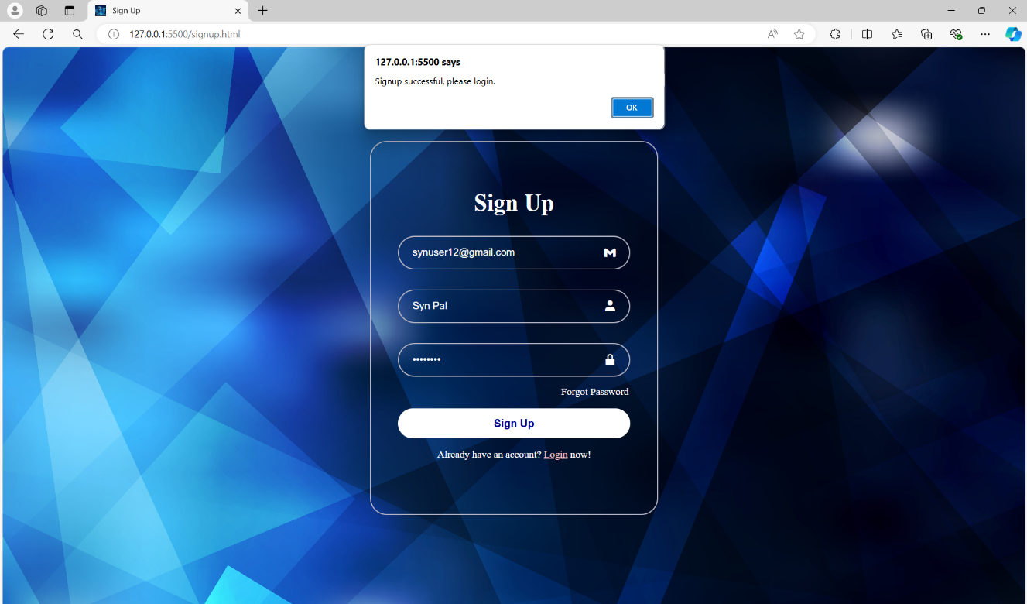

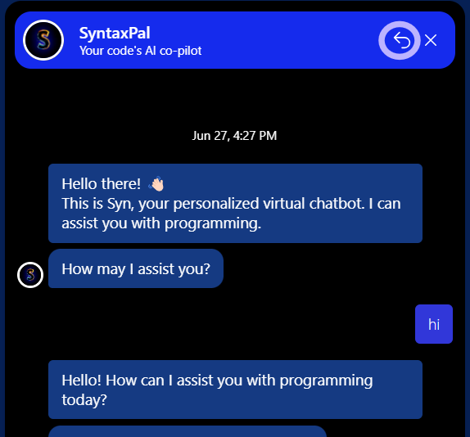

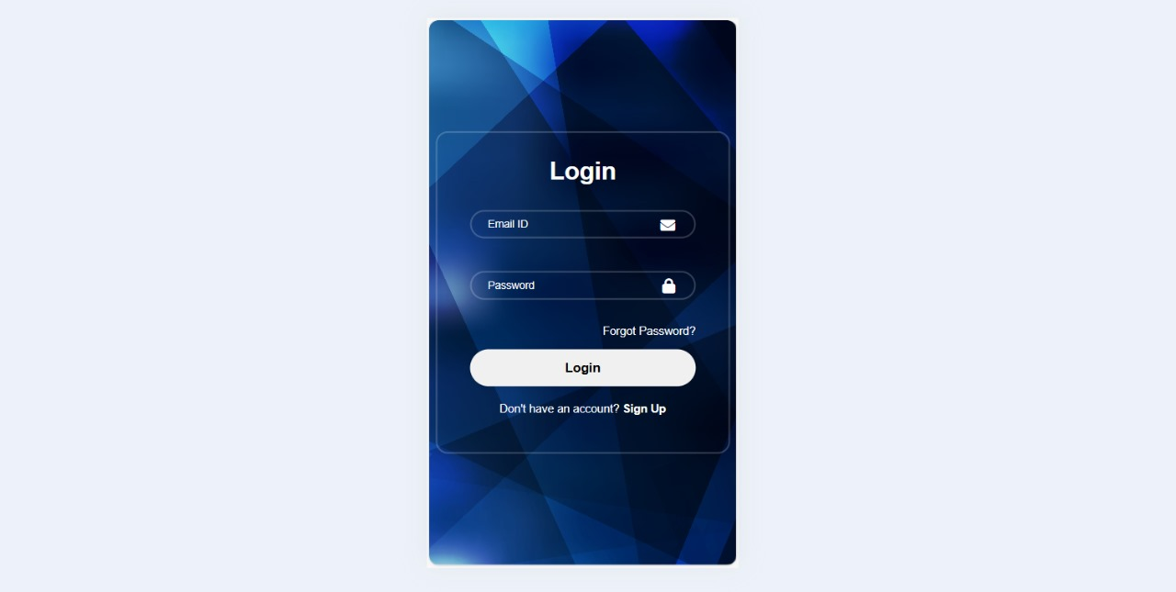

More images of the working of website can be viewed from the Google drive link :

<https://drive.google.com/drive/folders/1fwsTXY7Ej2ftl2NV3JNZHWPcM1UeWQOo>

A PPT presentation of tour of the website can be viewed at this link :

<https://docs.google.com/presentation/d/17RcmlZwtC1CT0dWwydXoPXzeVPTdxTcb/edit#slide=id.p1>

Possible Improvements :

* Adding History
* Editing Profile
* Exporting Chat

Conclusion :

* We learnt the necessary tech-stacks through various resources and also learnt how to choose the best when we have more than one choices. There have been many challenges which are solved through team-coordination. The project has been successfully completed through teamwork!